

Salesforce project



**🧾 Salesforce Project Documentation**

**Project Title: HandsMen Threads: Elevating the Art of Sophistication in Men's Fashion**

**📌 1. Project Overview**

**Objective**:  
To build a robust Salesforce application for a high-end men's fashion brand, **HandsMen Threads**, aimed at managing customer relationships, tracking sales, handling maintenance requests, and ensuring personalized communication using automation and custom development.

**🚀 Project Phases**

**Phase 1: Architecture & Planning**

* Define custom objects (Customer__c, Order__c, Product__c, etc.)
* Set up relationships, formula fields, and roll-up summaries.
* Establish validation rules, automation (flows, process builders), Apex triggers, and batch jobs.
* Design email templates for transactional communication and customer engagement.

**Phase 2: Development**

* Create all required custom objects and fields.
* Implement automation using Salesforce Flows and Apex.
* Configure security through profiles, roles, and sharing rules.
* Develop batch jobs for scheduled updates (e.g., loyalty status).
* Finalize email templates for notifications.

**Phase 3: Testing & QA**

* Perform unit testing for each component (flows, triggers, batch jobs).
* Conduct end-to-end testing using real-world test scenarios.
* Execute performance and security validation checks.

**Phase 4: Deployment & Training**

* Deploy the solution to production using change sets.
* Provide hands-on user training for business stakeholders.
* Offer post-go-live support and bug resolution.

**📄 Deliverable**

* **Solution Design Document** that includes:
  + Entity-Relationship Diagram (ERD)
  + Object Model
  + Data Flow Diagrams
  + Automation Strategy (flow maps, scheduled jobs, trigger logic)

**Creating Developer Account**

Creating a developer org in salesforce.

1. Go to <https://developer.salesforce.com/signup>
2. On the sign up form, enter the following details :

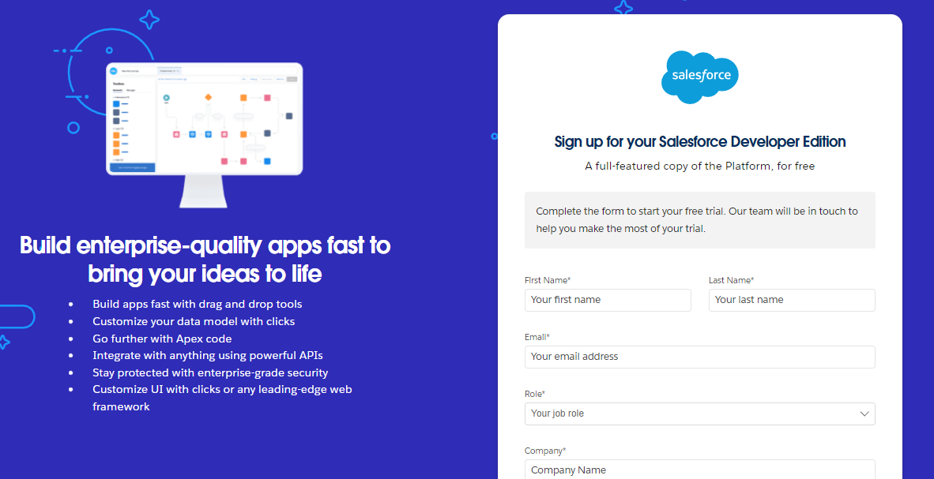

1. First name & Last name
2. Email
3. Role : Developer
4. Company : College Name
5. County : India
6. Postal Code : pin code
7. Username : should be a combination of your name and company

This need not be an actual email id, you can give anything in the format : [username@organization.com](mailto:username@organization.com)

Click on sign me up after filling these.

**Account Activation**

1. Go to the inbox of the email that you used while signing up. Click on the verify account to activate your account. The email may take 5-10mins.

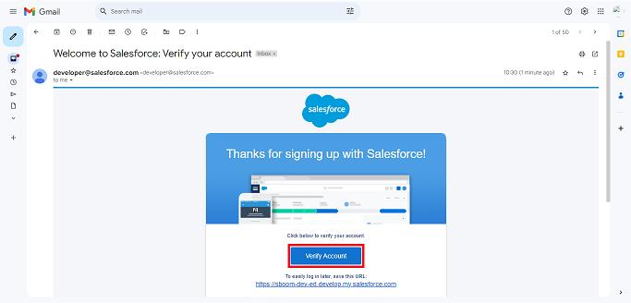

1. Click on Verify Account
2. Give a password and answer a security question and click on change password.

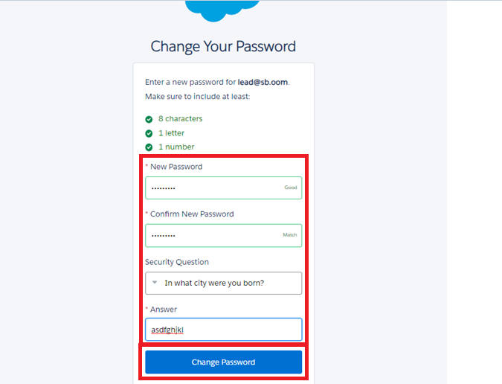

1. Then you will redirect to your salesforce setup page.

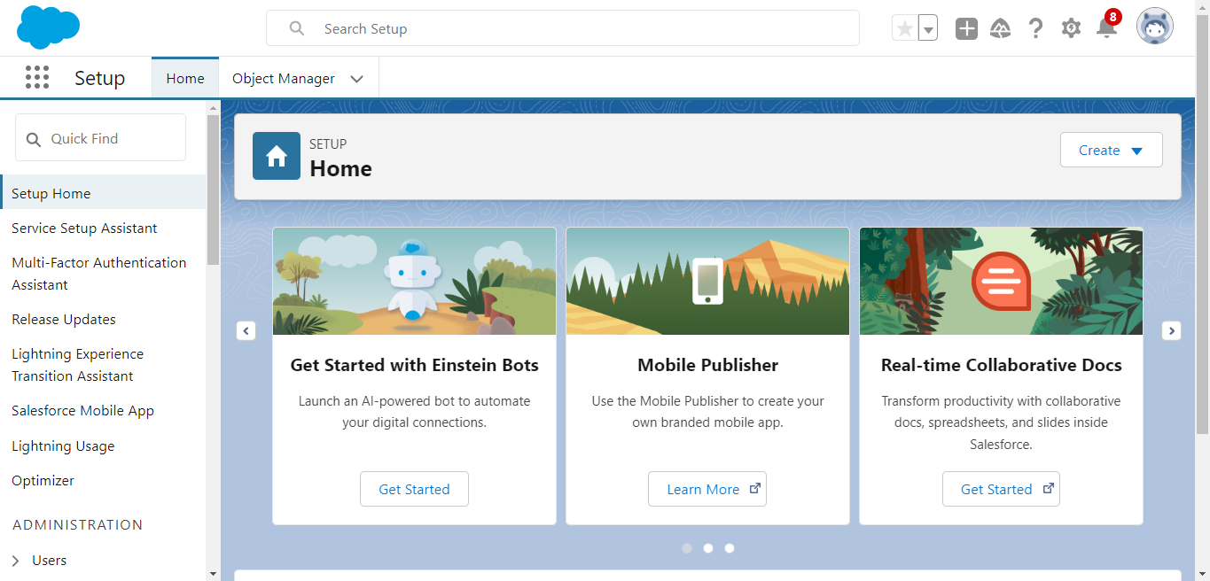

**2. Custom Objects**

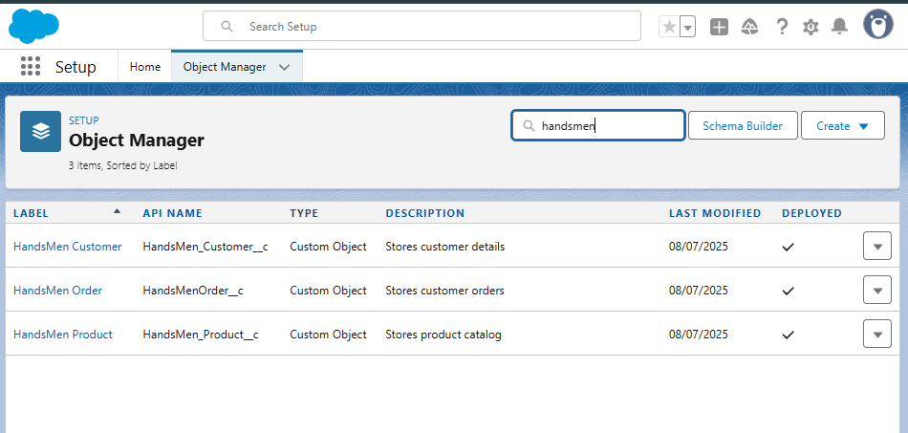

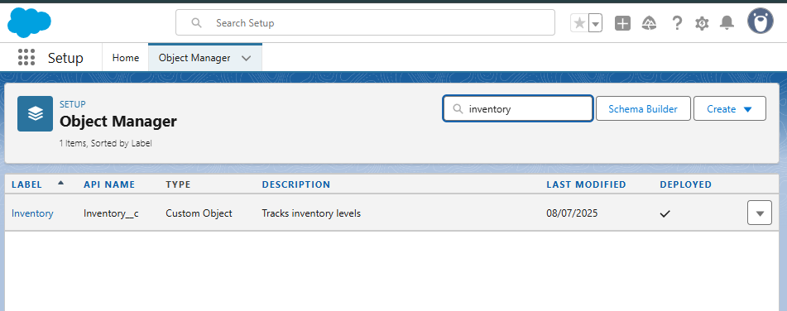

.

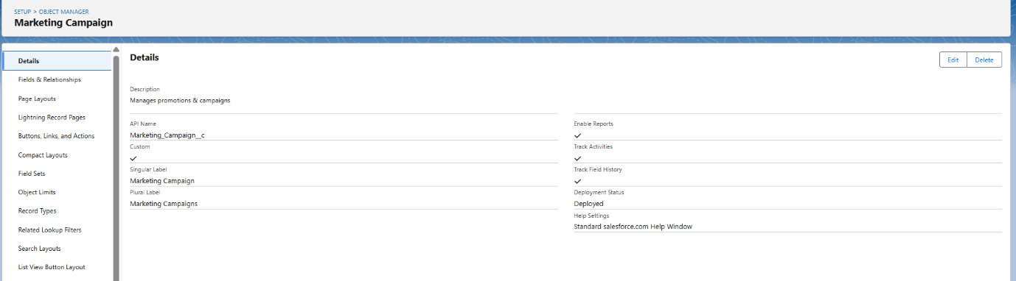Top of Form

Bottom of Form

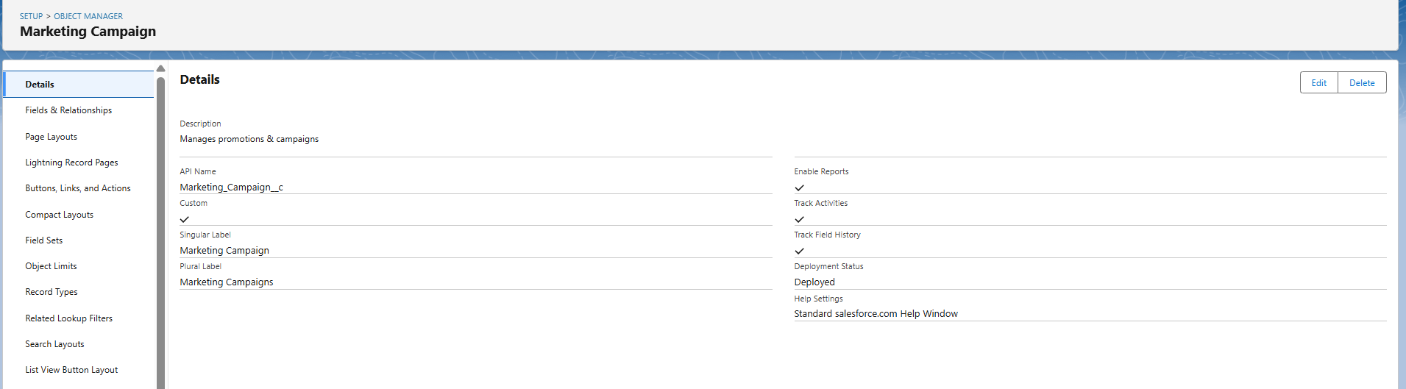

**Creating a Custom Tab – HandsMen Customer**

To make the HandsMen Customer object easily accessible from the app navigation bar:

1. **Go to Setup** → Search and open **Tabs**.
2. Click **New** under **Custom Object Tabs**.
3. Select **Object**: *HandsMen Customer*.
4. Choose a **Tab Style** (e.g., user icon).
5. Set **Tab Visibility** for user profiles.
6. Optionally, add the tab to a custom app via **App Manager**.

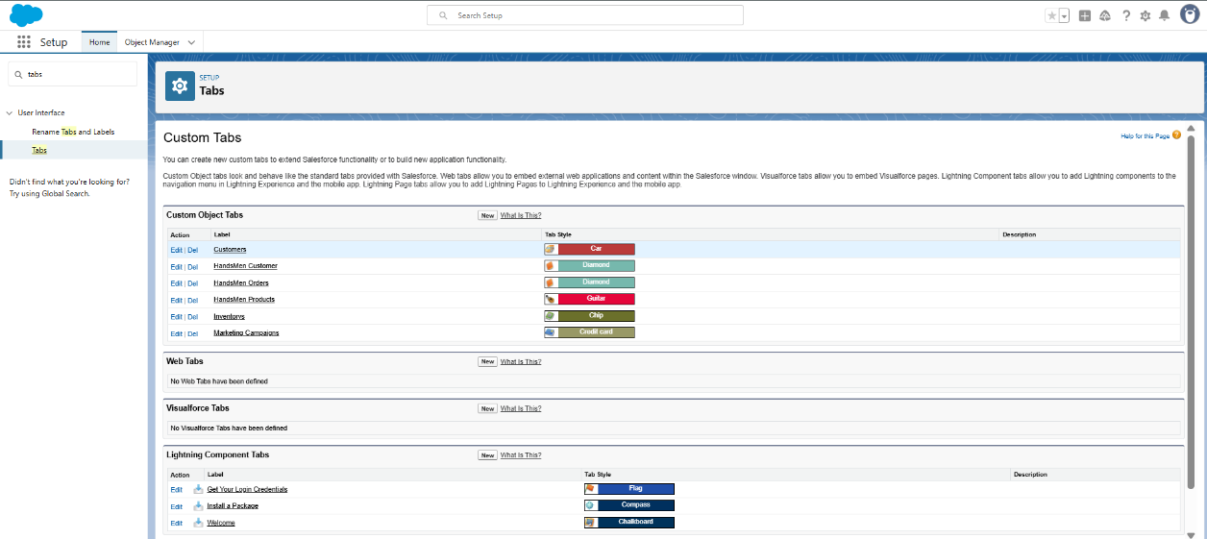

Creating a Lightning App

**Go to Setup** → Search **App Manager**.

Click **New Lightning App**.

Enter **App Name**, description, and logo (optional).

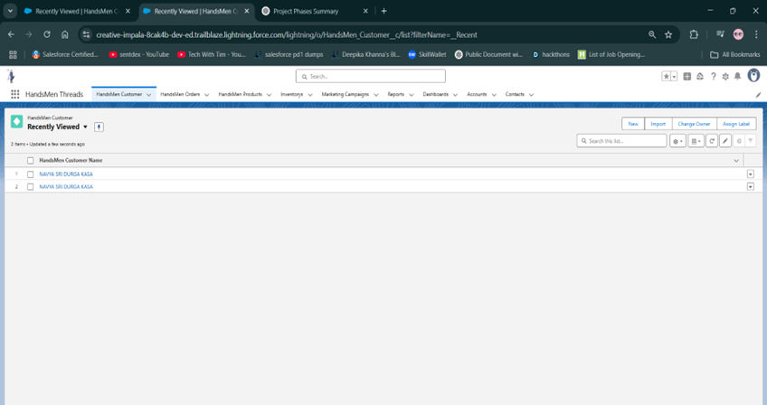

**Creating a Field – HandsMen Customer (Short Note)**

1. Go to **Object Manager** → Select **HandsMen Customer**.
2. Click **Fields & Relationships** → Click **New**.
3. Choose a **Field Type** (e.g., Text, Email, Number).
4. Enter **Field Label**, Length, and other properties.
5. Set **Field-Level Security** and **Page Layouts**.
6. Click **Save**.

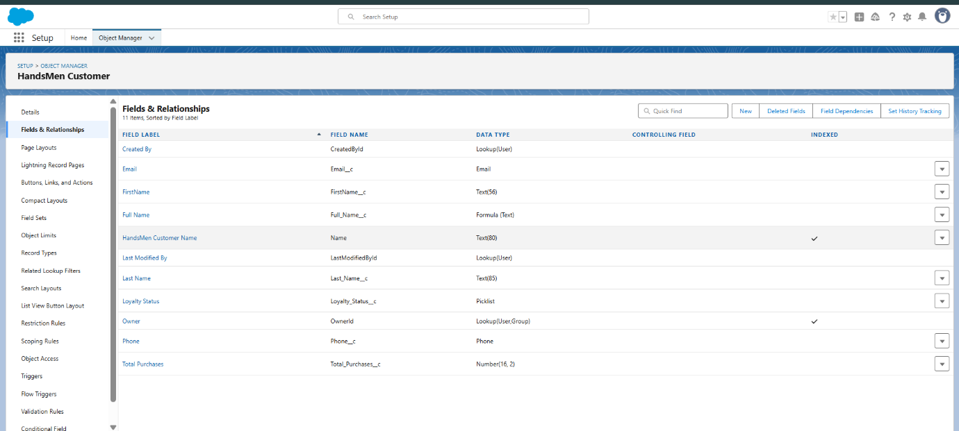

**Validation Rule**

1. Go to **Object Manager** → Select the object (e.g., *HandsMen Customer*).
2. Click **Validation Rules** → Click **New**.
3. Enter **Rule Name** and **Error Condition Formula**.
4. Add a clear **Error Message** and choose **Error Location**.
5. Click **Save**.
6. **Validation Rules**

|  |  |  |
| --- | --- | --- |
| **Object** | **Field** | **Validation Rule** |
| HandsMen Order__c | Total_Amount__c | Total_Amount__c <= 0 |
| Inventory__c | Stock_Quantity__c | Stock_Quantity__c < = 0 |
| HandsMen Customer__c | Email | NOT CONTAINS(Email, "@[gmail.com](http://gmail.com/)") |

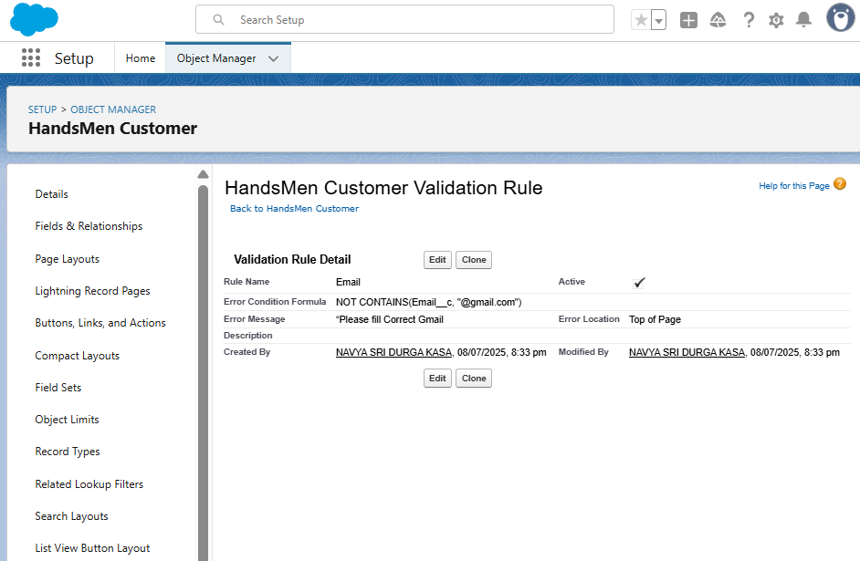

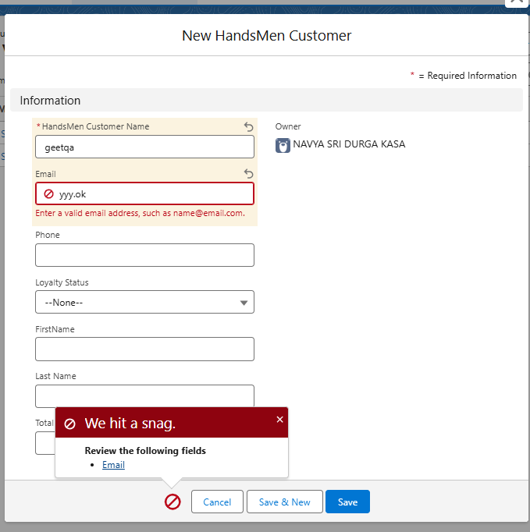

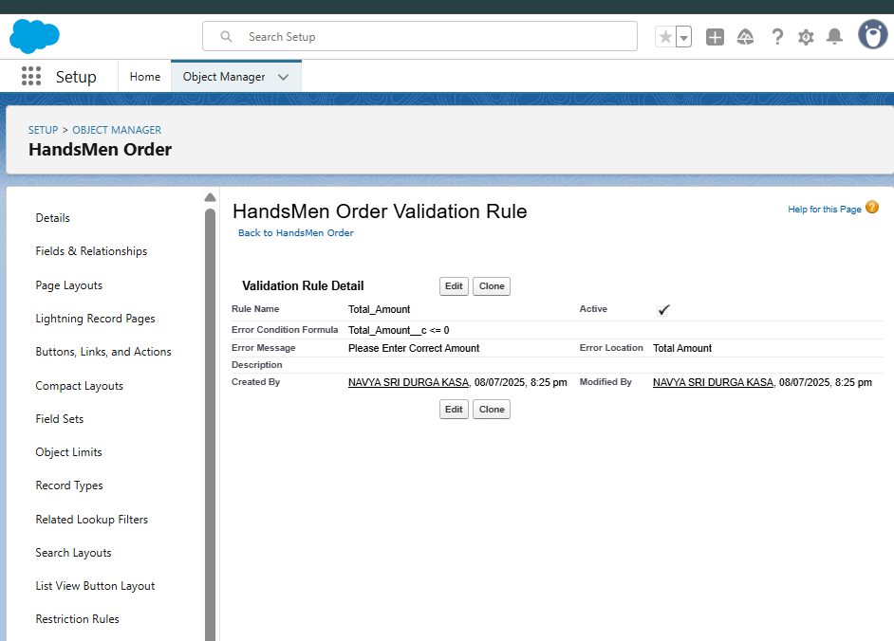

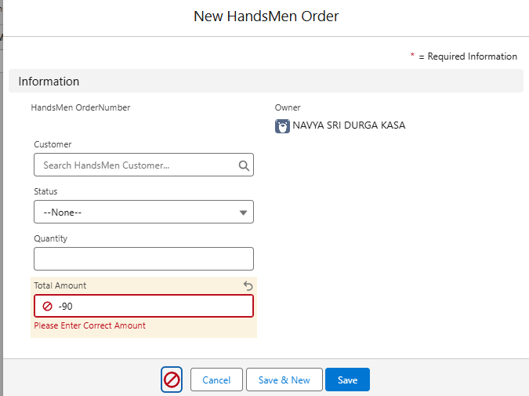

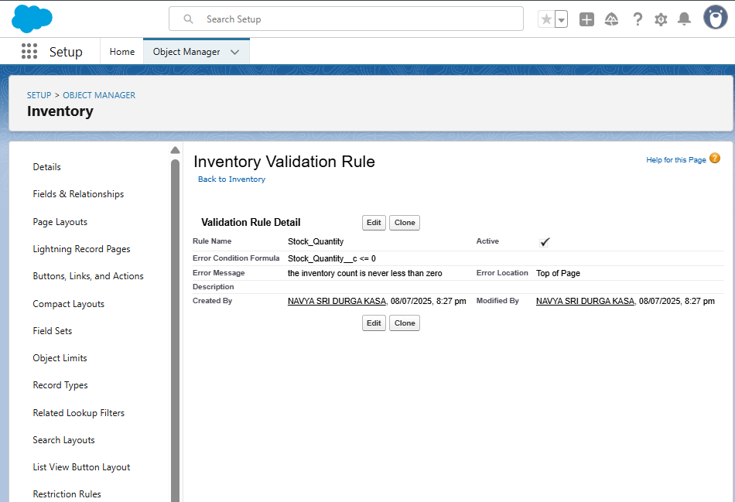

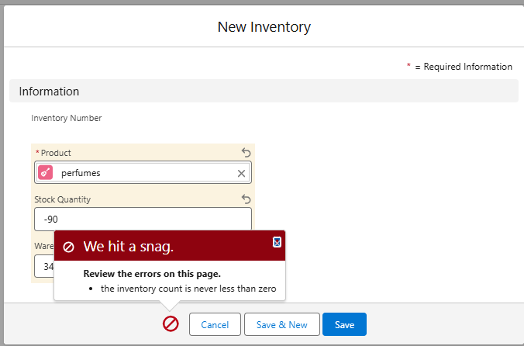

**Creating a Profile – Short Note**

1. Go to **Setup** → Search **Profiles**.
2. Click **Clone** next to an existing profile (e.g., Standard User).
3. Enter a **new profile name**.
4. Click **Save**.
5. Modify permissions as needed (object, field, tab access, etc.).

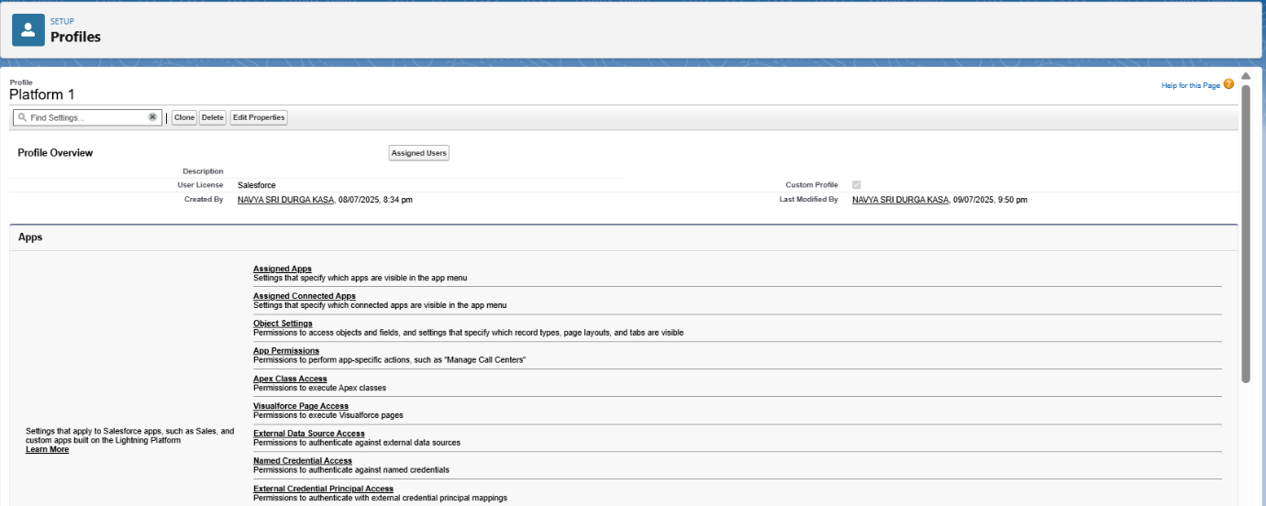

**Creating Profile**

Go to setup → type profiles in quick find box → click on profiles → clone the desired profile (Standard user) → enter profile name (Platform 1) → Save.



While still on the profile page, then click Edit.

Scroll down to Custom Object Permissions and Give access permissions for HandsMen products and Inventory objects.

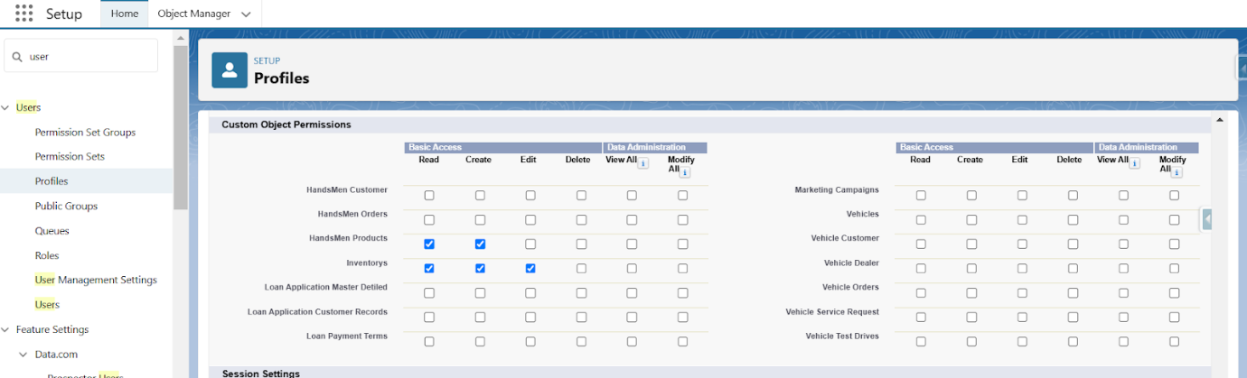

Scroll down and Click on Save.

**Roles in Salesforce – Explained Simply**

**Roles** in Salesforce define **data visibility** in the organization. They help control **who can see whose records** in the system.

**✅ Key Points:**

* Roles work with **Role Hierarchy**.
* Higher roles can see the data of users **below them** in the hierarchy.
* Roles do **not control permissions** (that’s done by profiles).

**🧭 Example:**

If a **Sales Manager** is above a **Sales Rep** in the role hierarchy, the manager can see all records owned by the rep.

**🔧 To View or Set Roles:**

* Go to **Setup** → Search for **Roles**.
* View or edit the **Role Hierarchy**.
* Assign roles to users under **User Details**.
* **Creating Sales Manager Role:**

Go to quick find → Search for Roles → click on set up roles.

Click on Expand All and click on add role under whom this role works(Here Click AddRole Under CEO role).

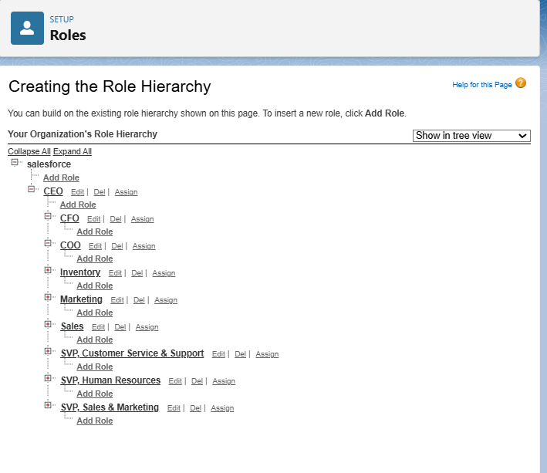

**Create User**

Go to setup → type users in quick find box → select users → click New user.

Fill in the fields

First Name : Niklaus

Last Name : Mikaelson

Alias : Give an Alias Name

Email id : Give your Personal Email id

Username : Username should be in this form: text@text.text

Nick Name : Give a Nickname

Role : Sales

User license : Salesforce Platform

Profiles : Platform 1

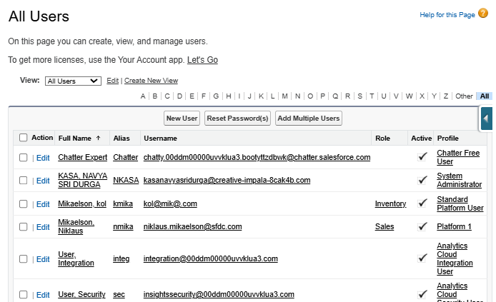

Go to setup → type “permission sets” in quick search → select permission sets → New.

Enter the label name as “Permission_Platform_1” → save.

Under Apps Select object settings.

Click on Customer object → click on Edit → under object permission check for read, create, edit, delete for HandsMen Customer object.

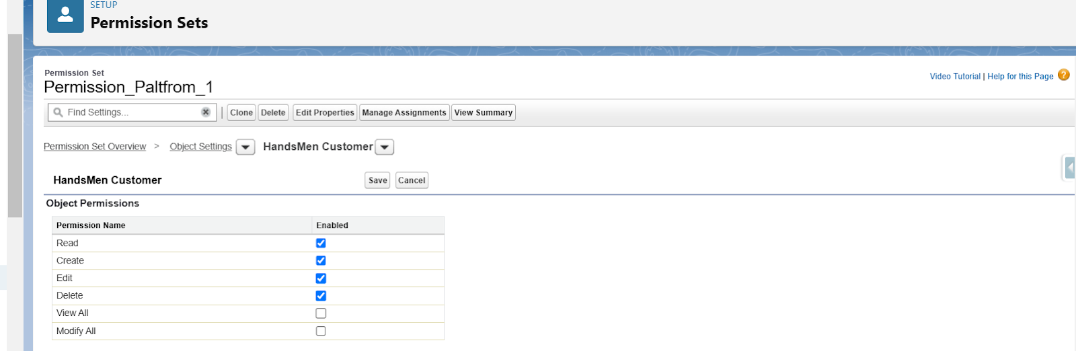

Click on Save.

Repeat from step 3 and give permission for read, create, edit and delete on order object.

After saving the permission click on the Manage assignment

Click on Add Assignment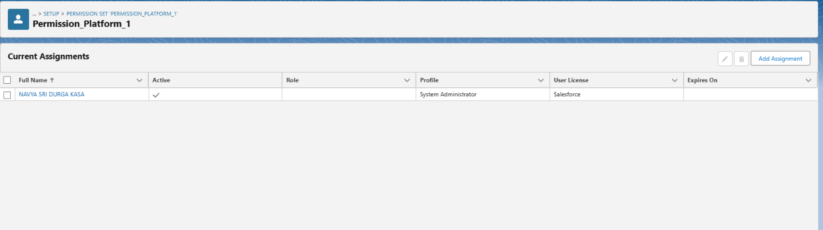

Now select the users(any one user with the profile “Platform 1”) and click on Next.

Click on Assign

Click on Done.

**Steps to Create a Classic Email Template**

Go to Salesforce Setup

Click on the Gear Icon (⚙) in the top-right corner and select Setup.

Navigate to Classic Email Templates

In Quick Find, search for Classic Email Templates and click on it.

Click "New Template

Choose Text, HTML (with Classic Letterhead), Custom (without Classic Letterhead), or Visualforce.

Select HTML (with Classic Letterhead) for a formatted email.

Fill in Template Details

Folder: Select "Unfiled Public Email Templates" (or create a new folder).

Available for Use: ✅ (Check this box)

Email Template Name: Order_Confirmation_Email (or appropriate name).

Encoding: UTF-8 (default).

Subject: Your Order has been Confirmed

HTML Body:  
  
*<p>Dear {!Order__c.Customer__c},</p>*

*<p>Your order #{!Order__*[*c.Name*](http://c.name/)*} has been confirmed!</p>*

*<p>Thank you for shopping with us.</p>*

*<p>Best Regards,</p>*

*<p>Sales Team</p>*

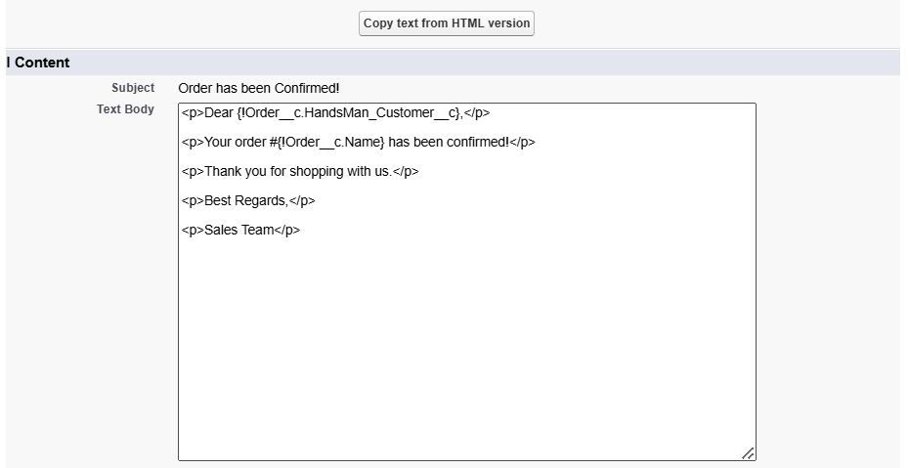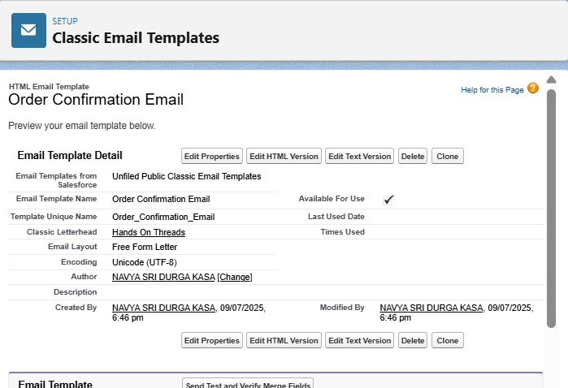

Create Remaining Email Template with the name "**Low Stock Alert**" and "**Loyalty Program Email**" as mentioned in the Email Template description.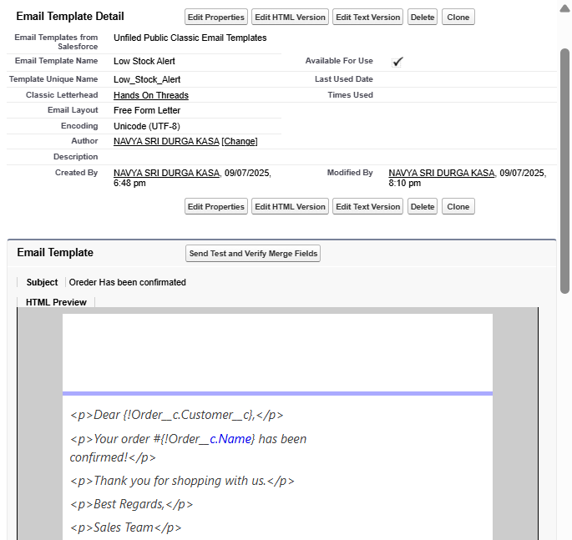

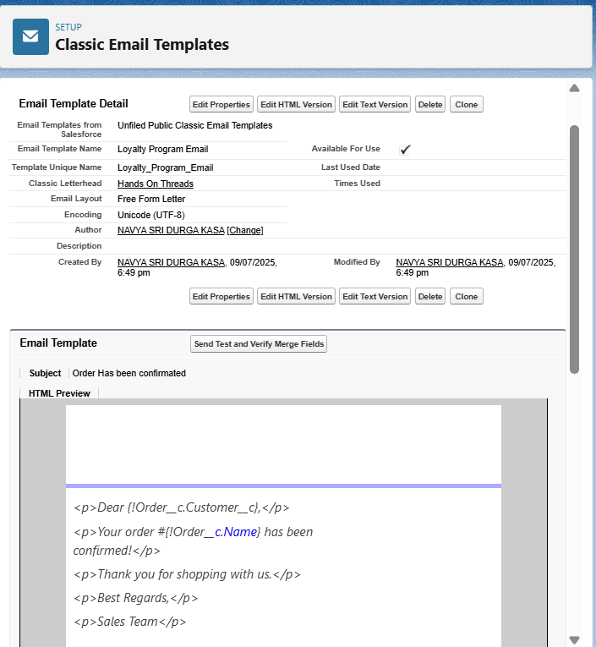

Create an email alert to send an email when an order is confirmed.

**Steps to Create an Email Alert**

Go to Setup

In Quick Find, search for Email Alerts and click on it.

Click "New Email Alert"

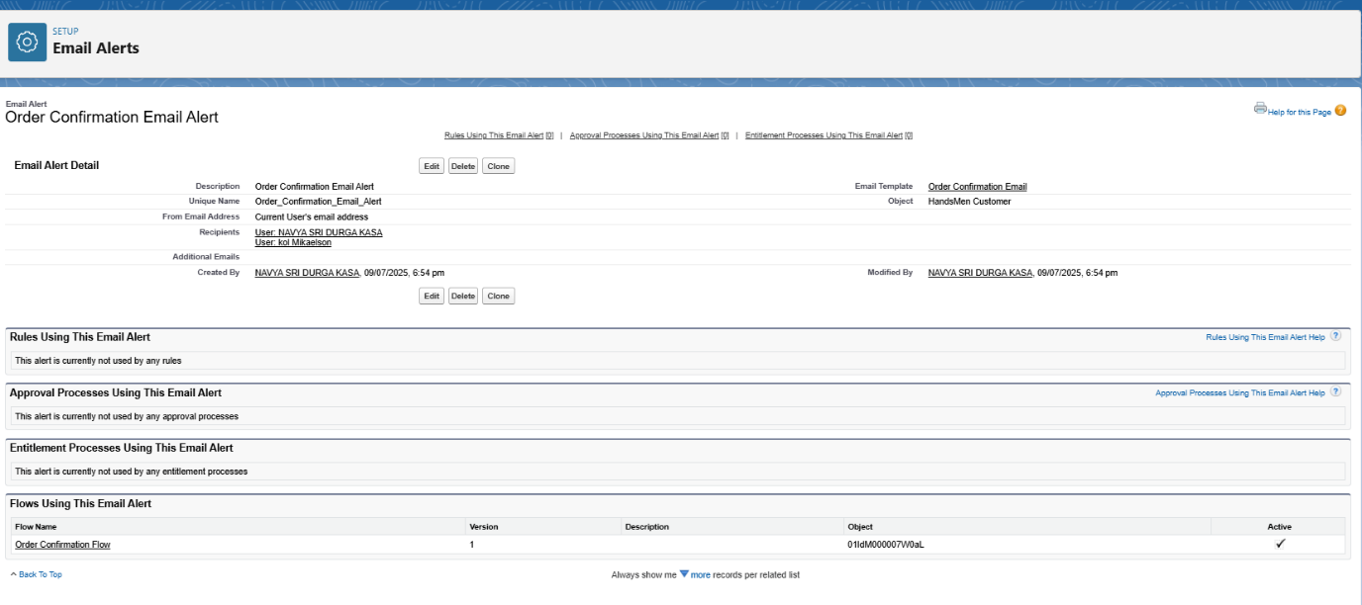

**Flows in Salesforce – Short Note**

**Flows** are automation tools in Salesforce that let you perform tasks like updating records, sending emails, or creating new records — all without code.

**🛠️ Types of Flows:**

1. **Record-Triggered Flow** – Runs when a record is created/updated/deleted.
2. **Scheduled Flow** – Runs at a specific time (e.g., daily at 10 AM).
3. **Auto-Launched Flow** – Runs in the background, triggered by Apex or other automation.
4. **Screen Flow** – Has a user interface (used for data entry forms).

**✅ Use Cases:**

* Auto-update loyalty status based on purchases.
* Send welcome emails to new customers.
* Assign follow-up tasks after order completion
* **Order Confirmation Email (Record-Triggered)**
* Go to Setup → Flow
* In Quick Find, search for Flows and click on it.

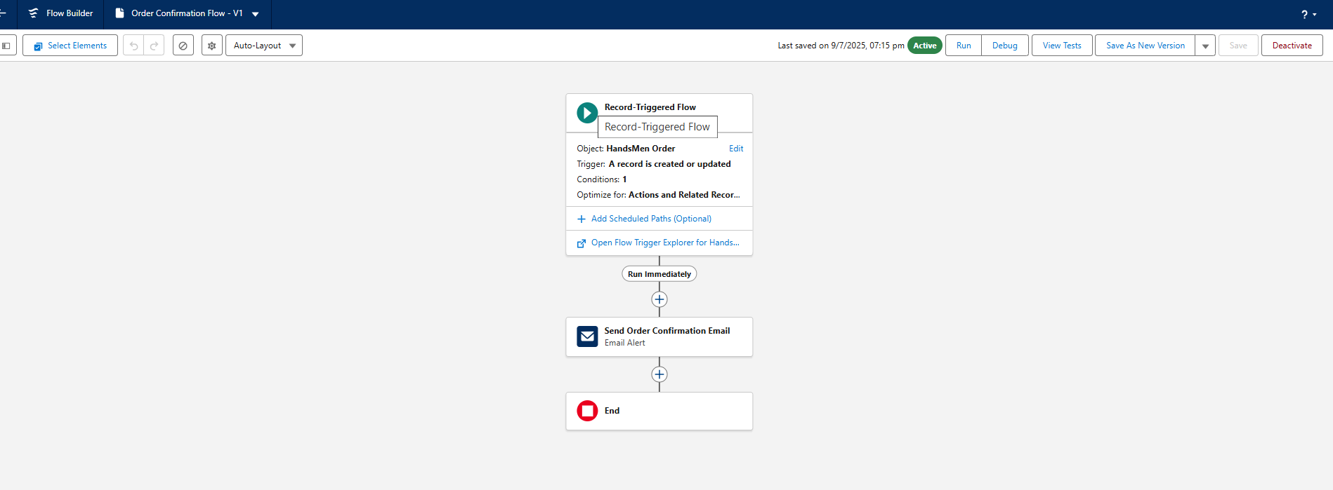

**Create Stock Alert Email (Record-Triggered)**

Go to Setup → Flows → New Flow

Select Record-Triggered Flow → Click Create.

Set Flow Trigger Details

Object: Inventory__c

Trigger: When a record is created or updated

Condition:

Field: Stock_Quantity__c < 5

Select: Every time a record is updated and meets the condition requirements

Click Done.

Add an "Action" Element

Click the "+" icon → Select Action.

Action Type: Send Email Alert

Create a new Email Alert (Similar to the Order Confirmation setup).

Recipient: Inventory Manager.

Save & Activate the Flow

Name: Stock Alert Flow

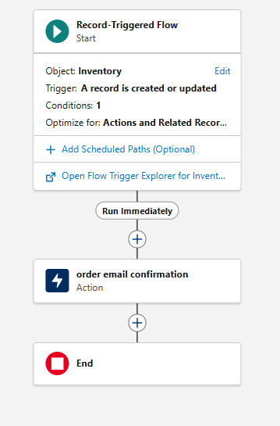

**Loyalty Status Update :**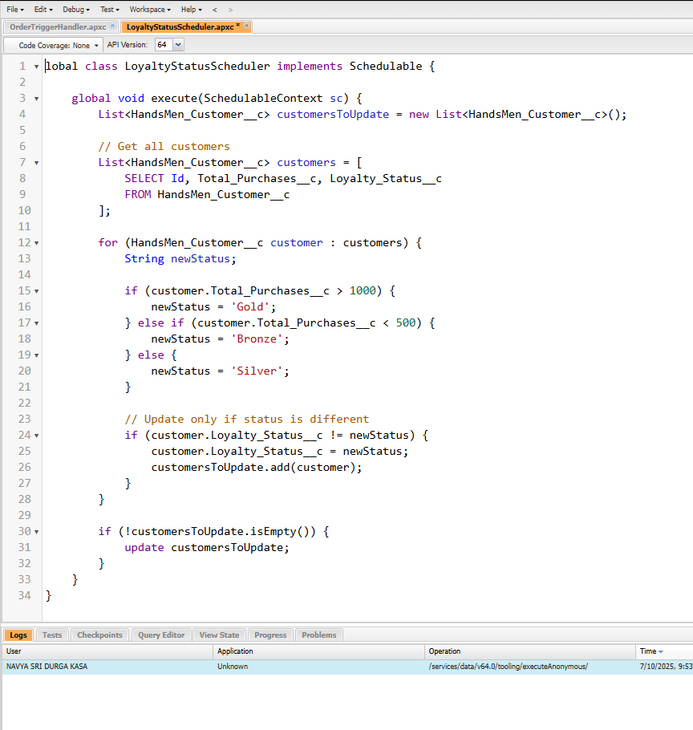

**Create an Apex Class**

**Go to Setup → Click on the gear icon → Select Developer Console.**

**Then we can see the Developer console. Click on the developer console and you will navigate to a new console window.**

**To create a new Apex Class follow the below steps:   
Click on the file → New → Apex Class.**

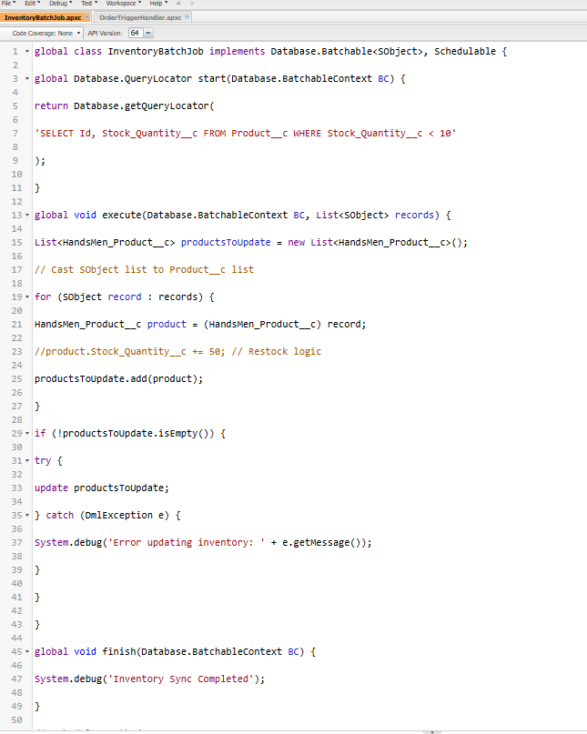

**A Scheduled Job is used to run Apex code automatically at a specific time or on a recurring schedule (daily, weekly, etc.).**

**For example, you can use it to:**

* **Send daily summary emails**
* **Run batch jobs every night**
* Clea Clean up old data every week

